1. **PROJECT DETAILS**

Complete the following table with respective project details (copy-paste as appropriate from last report):

|  |  |
| --- | --- |
| Project ID | P10142 |
| Project Name | GTM Comprehensive Medical and Rehabilitation Project |
| Project Location | <Butajira,SNNPR,Ethiopia > |
| Project Duration | 1/1/2021-31/12/2023 |
| Total approved budget amount (in EUR) | <24,727,941.37> |
| Total budget expenditure amount (in EUR) | <24,727,941.37> |
| Contract Partner | <Grarbet Tehadiso Mahber > |
| Other Implementing Partners | <None > |
| Responsible person at Partner / Project | <Mr.Desalegn Amanuel,Prof. Redda TekleHaimanot > |
| Date of report submission | < 15/1/2024> |
|  |  |
| Responsible person at CBM | <Samuel Bekele, Programme Officer> |

1. **NARRATIVE REPORT**

## **To what extent were the Objectives achieved?**

***The overall objective of the project:*** *t*o improve quality of life of persons with disability and those at risk of disability through the provision of comprehensive preventive, curative and rehabilitative services in central rural Ethiopia between January, 2021 and December, 2023.

In our pursuit of delivering patient centered healthcare services, GTM specialty hospital has been committed to elevating the standard of patient care through a holistic and comprehensive approach to medical and rehabilitation services. This initiative aims to integrate different medical and rehabilitation services like Eye health, Ear and Hearing Care, Physical impairment rehabilitation & Epilepsy, ensuring that our patients receive effective and personalized care throughout their healthcare journey.

**During the implementation of the project activities, the following challenges were encountered:**

1. **High prices of medicines and the unavailability of IOL**:-The high price of medicines and the unavailability of IOL (18-24D) were major concerns, as GTM performs more than 2,000 cataract surgeries in a year using its two base centers in Butajira and Batu. In order to provide high-volume and quality cataract surgery, the supply chain of IOL and other essential medicines has to be resolved. GTM still requires assistance in this regard.
2. **Unavailability of polypropylene, a raw material, for the production of braces for persons with disabilities**: -This has been a major obstacle to the production of mobility appliances over the last three years. GTM secured annual supplies of polypropylene from Cheshire homes in 2022. However, the unavailability of polypropylene and the high cost of producing crutch handles make it difficult to provide assistive devices for persons with disabilities.
3. **The CBM financial contribution for low vision services has been discontinued**: - Since there was no funding set aside beginning in 2023 from CBM, the low vision services, which included providing ongoing training and counseling to low vision patients and caretakers and routine follow-up for patients who acquired low vision devices, were compromised. The first-in-kind low vision was first started in GTM after a kind donation from CBM, and it is one of the most prominent supports for our rural beneficiaries. Stopping the support before there has been enough discussion and agreement would significantly affect the goal of improving the quality of life of low-vision patients.
4. **Unavailability of hearing aids**: During the project period, a lot of patients were identified as candidates for a new hearing aid. As there have been no hearing aids, we are not able to help them. Despite the serious consequences and burden that come with hearing loss, the problem is made worse by the lack of hearing aids.
5. **Surgical camps for ENT patients:** The plan to organize the surgical camp in collaboration with St. Paul Hospital and Dr. Uta Froeschl once a month could not materialize due to different reasons. Apart from the lack of sufficient budget allocation for this particular activity, security concerns and issues at St. Paul Hospital made it difficult to achieve the plan successfully.

**Strategy changes (Budget reallocation)**

In order to make the greatest use of the allotted funds, two planned project activities' budgets were re-designated or reallocated during the project period (2022) in consultation with CBM-CO. The previously approved budget for procurement of low vision devices, under activity 06.01 of the approved budget of P-4081 GTM Comprehensive Medical and Rehabilitation Services, was reallocated to cover costs linked to the provision of comprehensive low vision services (Activity 05.01: Low Vision Screening of Children and Adults). This is due to the fact that GTM had sufficient stocks of low-vision devices for the reporting period. In addition, the plan to organize an experience-sharing visit of our senior optometrist to Kenya was also rescinded since our two senior optometrists underwent rigorous virtual training on low vision from CBM Low Vision Advisor, Dr. Karin van Dijk, which lasted two weeks. Instead, the budget was reallocated to provide safe guarding training (01.07: Safeguarding training for project staff) and purchase frames and lenses (06.01: Equipment and maintain stocks for low vision testing tools, materials, and spectacle frames).

***The Specific objective of the proposed project:*** *t*o improve efficiency and effectiveness of Comprehensive Eye Care, ENT, Epilepsy and Physical Rehabilitation Services addressing persons with disabilities and at risk of disability in Butajira town and its surrounding rural areas.

The successful implementation of comprehensive preventive, curative, and rehabilitative services has not been only met, but exceeded expectations, resulting in a significant improvement in the overall well-being and livelihoods of the target population. Through this three-year duration project, individuals with disabilities and those at risk have experienced significant improvements in health outcomes, increased participation in community activities, and marked improvements in their quality of life. This accomplishment highlights the project's commitment to making a lasting and meaningful impact on the lives of those it serves in central rural Ethiopia. In general, we contributed towards optimizing patient outcomes, enhance the quality of life, and promote a continuum of care that addresses both acute medical needs and long-term rehabilitation requirements.

# **To what extent were the planned Results achieved or not during the reporting period?**

**Table 1: Summary of performance in screening and treatment of patients from January, 2021 to December 2023**

|  |  |  |  |  |
| --- | --- | --- | --- | --- |
| **Key Results** | **Total project Target for two years** | **Jan 2021 to Dec,2023 actual achievement** | **Achievement of six months (July to Dec 2023)** | **Cumulative performance in percent for the three years** |
| 1.1 Eye patients screened and treated | 105,000 | 239,926 | 24,516 | 160% |
| 1.3 Lid surgeries performed | 5,300 | 2,416 | 216 | 46% |
| 1.4 Cataract surgeries performed ` | 9,000 | 11,078 | 1,123 | 123% |
| 1.5 Adults and children refracted | 30,000 | 37,353 | 4,247 | 125% |
| 2.1 Patients screened and treated for ENT problems | 45,000 | 65,349 | 9,200 | 145% |
| 2.5 ENT surgeries performed | 840 | 353 | - | 42% |
| 3.1 Persons with disability screened | 8,300 | 10,732 | 1,338 | 129% |
| 3.2 Persons rendered with physiotherapy service | 7,500 | 27,235 | 1,834 | 363% |
| 4.1 Newly enrolled patients with Epilepsy | 3,000 | 2,046 | 242 | 68% |
| 4.2 Epileptic patients will be followed up | 30,000 | 24,743 | 2,801 | 82% |

**Key activity implementation status**

The GTM Medical Rehabilitation Project has demonstrated significant success in various key result areas, affirming its commitment to improving the lives of persons with disability. Over the course of the three-year project period, the project has demonstrated exceptional performance in providing eye care, ENT, and rehabilitation services for individuals with disabilities, with an outstanding success rate exceeding 100 %. However, the report indicates a decline in performance regard to medical services rendered for persons with newly enrolled epilepsy patients, with an achievement rate of 68%. Recognizing this gap, the project team is strategically planning efforts to enhance awareness. The project team aim to boost the uptake of the epilepsy services within the community, specifically targeting individuals affected by epilepsy and their caregivers. There remains a great need to increase global awareness of the burden of epilepsy on individuals and their families, and its treatable nature[1].This will be achieved through the implementation of health education initiatives and the facilitation of focused group discussions. The decline in TT surgery achievement is due to the start of two CBM-funded trachoma projects in GTM catchment areas. This two-trachoma project employed TT case finders to conduct house-to-house case finding methodology to identify and offer free surgery to TT patients. As a result, the GTM center reduced the number of patients referred and receiving TT surgery. The reason for decrease performance of ENT surgical performance is stated above.

**Result 1: Quality eye care services provided**

Grarbet Tehadiso Mahber (GTM) is dedicated to providing high-quality eye care services to beneficiaries in rural central Ethiopia who have limited access to such services. Comprehensive and inclusive eye care services are crucial in preventing blindness. The eye care services involved the identification and management of eye conditions such as trachoma, cataracts, glaucoma, and other eye diseases. In this regard, providing accurate and appropriate refraction services, including eyeglasses, is an integral part of quality eye care services. Additionally, our field team at Buajira and Batu Centers work closely with governmental bureaus, non-profit organizations, and the community to extend our reach beyond our center’s walls. As a result of the eye care services rendered, patients are able to be cured of blinding eye diseases. Furthermore, preventive measures such as health education on the importance of regular eye examinations were provided to beneficiaries presenting at both GTM centers in Batu and Butajira.

**Result 2: Essential ENT services provided to rural people in central Ethiopia**

GTM continued providing essential ENT services with an emphasis on ear and hearing care during the reporting period. The ENT services provided include ear cleaning, administration of antibiotics to manage chronic ear conditions, and surgery for cases requiring intervention, such as tympanoplasties. As there are no governmental facilities in the GTM catchment area that provide ENT services, the beneficiaries are very much appreciative of the service they received. The diagnostic services, which included audiometry for hearing assessment and endoscopy for nasal and throat examinations, were essential for identifying and understanding ENT issues. The plan to organize surgical camps for patients who required advanced surgical intervention in close collaboration with Dr. Uta Froeschl of CBM and St. Paul's Hospital Millennium Medical College (SPHMMC) did not materialize during the reporting period. The plan to organize two surgical camps faced setbacks initially due to personal issues involving the surgeon, Dr. Uta. On the second occasion, the cancellation resulted from the ENT department at St. Paul declining to deploy Dr. Uta Froeschl and the residents. The department cited shortage of surgeons arising from their engagement in a national survey.

**Result 3: Locomotors rehabilitation services provided to persons with disabilities**

Persons with disabilities face many barriers to participating in all aspects of society. Locomotor rehabilitation services play a vital role in enhancing the quality of life for people with disabilities, particularly those with mobility impairments. GTM has improved the quality of life for people with disabilities by providing services that encompass medical, surgical, and assistive devices. This created an opportunity for beneficiaries to become self-sufficient and productive. Furthermore, community awareness of physical disability was raised.

**Result 4: Medical services provided to patients with Epilepsy in rural central Ethiopia**

One of the leading causes of neurological morbidity in central and rural Ethiopia is epilepsy. Within its center in Butajira, GTM operates an epilepsy clinic that is run by a qualified health officer. Persons with epilepsy are diagnosed, treated, and continuously followed at the center. The health officer uses clinical evaluation and medical history review to determine the type and severity of the seizures. He also consults our neurologist (Prof. Redda) on complicated cases. Persons with epilepsy are able to lead a normal and productive life after their neurological problem is properly managed using very affordable antiepileptic drugs (AED). Unfortunately, there are periods when there is shortage of AED the whole country. Ensuring a consistent and affordable supply of antiepileptic medication is one of the main challenges. Efforts are being made to address any barriers to medication access in consultation with Ethiopian Pharmaceutical Supply Services (EPSS).

# **What key Activities were implemented and what Activities were planned but not implemented in the reporting period?**

|  |  |  |
| --- | --- | --- |
| Key Activity No. | Activity Name | Status, achievements, no. of beneficiaries |
| 1.1 | Eye patients screened and treated | Achieved (89%). no. of beneficiaries (24,516) |
| 1.3 | Lid surgeries performed | Achieved. no. of beneficiaries (216 lids operated) |
| 1.4 | Cataract surgeries performed ` | Achieved. (75%) No. of beneficiaries: -1,123 |
| 1.5 | Adults and children refracted | Achieved. (85%). No of beneficiaries. 4,247 |
| 2.1 | Patients screened and treated for ENT problems | Achieved. (123%). No of beneficiaries. 9,200 |
| 3.1 | Persons with disability screened | Achieved. No of beneficiaries. 1,338 |
| 3.2 | Persons rendered with physiotherapy service | Achieved. No of beneficiaries. 1,834 |
| 4.1 | Newly enrolled patients with Epilepsy | Achieved. No of beneficiaries. 242 |
| 4.2 | Epileptic patients will be followed up | Achieved. No of beneficiaries. 2,801 |

**Result 01: Quality eye care services provided**

* 1. **Eye patients screened and treated**

A total of 20,657 adults (Males: 10,841 and Females: 9,816) and 3,859 children (Boys: 1,714 and Girls: 2,145) received comprehensive eye care services using GTM base Centers in Butajira and Batu. The eye examination is provided by GTM’s senior ophthalmologists, cataract surgeons, ophthalmic nurses and optometrists. Emphasis was given to the major cause of blindness such as Trachoma, Refractive error and Cataract. GTM rendered these services to the patients came from all across the country. The outreach eye care teams also refer patients with low vision and those needing advanced interventions to both GTM Centers. Additionally, GTM worked to improve the skills of the eye care staff by offering ongoing training led by senior ophthalmologists and by having its employees attend seminars and workshops organized by its partners.

* 1. **Active Trachoma cases treated with TTC**
  2. **Lid surgeries performed**

Among patients screened for eye problems, a total of 1,017 adults (Male: 513 and Female: 504) and 409 children (Boys: 217 and Girls: 192) were diagnosed as having active trachoma and were treated with TTC eye ointment. Patients presenting with inward growth of eyelashes (TT) undertook surgery for entropion trachomatous trichiasis (TT). A total of 216 lid surgeries were performed for 212 Adults (Male: 56 and Female: 156). GTM, in collaboration with CBM, also kicked two trachoma projects using WHO recommended SAFE strategy in its 11 operational districts in Southern Region.

* 1. **Cataract surgeries performed**

GTM provides cataract surgery to beneficiaries in the central rural Ethiopia. During the reporting period a total of 1,109 adults (Male: 554 and Female: 555) and 14 children (Boys: 6 and Girls: 8) were operated for blinding cataract. Emphasis is given to preparation and outcome of patients operated for cataract. All of the cataract operation were performed after proper biometry measurements, using Auto-keratometer and the latest A-B scanner, conducted by GTM’s optometrists. In this regard, mandatory CSOM were also undertaken to monitor and assesses the quality of cataract surgery. This ensure successful visual outcomes and the results are encouraging.

In addition to the routine service delivery, GTM involved in hands-on academic training for residents in collaboration with St. Paul’s Hospital Millennium Medical College (SPHMMC). The ophthalmology residents are attached at GTM center in Butajira for a hands-on training. Each resident stays for a period of 6 weeks. Feedback from the residents and SPHMMC Ophthalmological Department has been positive and encouraging.

* 1. **Adults and children refracted**

Optometry service is one of the flagship activities of the project as refractive error is one of the major cause of avoidable blindness. During the reporting period, GTM optometrists refracted a total of 4,102 adults (Male: 2,473 and Female: 1,629) and 145 children (Boys: 67 and Girls: 78) to correct the distance and near visual problems. Low cost and good quality eyeglasses were also produced and dispensed for beneficiaries needing glasses. A total of 1,324adults (Male: 828 and Female: 496) and 48 children (Boys: 24 and Girls: 24) received spectacles to correct refractive errors.

* 1. **Adults and children educated**

Health education sessions were organized at the GTM centers in Butajira and Batu to educate and sensitize the community regarding eye health. During the reporting period, a total of 41,314 Adults [Male: 21,682 and Female: 19,623] and 7,718 Children [Boys: 3,428 and Girls: 4,290] attended the health education sessions on prevention and treatment of common eye diseases.

**Result 02: Essential ENT services provided to rural people in central Ethiopia**

* 1. Patients screened and treated for ENT problems
  2. Patients treated for ear infection
  3. Removal of foreign body for adults and children
  4. Audiometry performed for persons with Hard of Hearing
  5. ENT surgeries performed

GTM continued to provide advanced ENT care for the community in its operational and adjacent districts through its walk-in clinic at Butajira. During the reporting period, 5,790 adults (Male: 2,987 and Female: 2,803) and 3,410 children (Boys: 1,284 and Girls: 2,126) were screened and treated for ENT problems. Among these, 721 adults (Male: 405 and Female: 316) and 632 children (Boys: 255 and Girls: 377) were treated for ear infections at the center. GTM renders audiometry for patients presenting to its center with hard of hearing and recurrent ear infection. During the reporting period, audiometry was performed for 582 adults (Male: 296 and Female: 286) and 213 children (Male: 32 and Female: 181). Although there are many patients with hearing loss, who could benefit from the hearing aids, high cost and shortage of hearing aids has become a major challenge for providing this service.

**Result 03: Locomotor rehabilitation services provided to persons with disabilities**

Providing locomotor and rehabilitation services to target beneficiaries was an essential project activity of GTM during the six months. Using GTM's base center in Butajira, a total of 778 adults (Male: 391, Female: 387) and 560 children (Boys: 368, Girls: 192) were screened for physical disability. GTM physiotherapist and his assistants provided physiotherapy services for 1,061 adult clients(Male: 542, Female: 519) and 773 children clients (boys: 509, girls: 264) on active follow up.

* 1. **Patients treated with PoP for Club foot**

Patients with club foot are treated at GTM rehabilitation unit using the Ponseti technique. In this regard, the rehabilitation team applied PoP for 338 clients (male:-250 and female:-88) needing the service. The service was closely supported by Hope Walks.

* 1. **Appliances and devices produced and distributed**
  2. **Appliances and devices maintained**
  3. **Orthopedic Surgery**

Mobility appliances namely, crutches, braces, orthopedic shoes, Ankle-foot orthoses (AFO) and Knee-Ankle-Foot orthoses (KAFO) are produced inside GTM orthopedic workshop for persons with physical disability. This will enable persons with physical disability to be self-sufficient in regard to mobility and become productive. In the reporting period, Appliances and locomotive devices were distributed for 275 adults (Male: 170, Female: 105) and 121 children (Male: 68, Female:53). Moreover, maintenance of appliances was done for 73 adults (Male: 36, Female: 37) and 15 children (Male: 31, Female: 15). Furthermore, GTM’s orthopedic surgeon performed clubfoot surgical procedure for 29 children [Boys 25, Girls: 4].

**Result 04: Medical services provided to patients with Epilepsy in rural central in rural central Ethiopia**

**4.1 Newly enrolled patients with Epilepsy**

**4.2 Epileptic patients will be followed up**

Care and treatment for persons with epilepsy was also one of GTM's central activities during the reporting period. 114 adults (Male: 70 and Female: 44) and 128 children (Male: 78 and Female: 50) were newly enrolled to the epilepsy clinic. Additionally,2,072 adults (Male:1230 and Female: 842) and 729 children (Boys: 442 and Children: 287) visited the epilepsy clinic for an active follow up. The seasonal availability and high price of medicines for the treatment of Epilepsy continued to be a major challenge for the reporting period.

## **Activity Forecast (only for ANR)**

* For ongoing projects, list key activities (activity name and number) that are planned to be implemented in the next reporting period.

The project was successfully completed during the reporting period. All of the planned activities are achieved throughout the project’s three-year duration.

# **Internal or external organizational challenges or changes that have affected project implementation during the reporting period**

* Specify any significant internal organizational challenges or changes (e.g. restructuring, governance, and mandate) and staff changes (e.g. departures or shifts in key positions, technical staff or senior personnel).
* Report on any significant external challenges or changes relevant to the project implementation or partner operations that have negatively or positively affected project implementation during the reporting period (e.g. changes in national legislation, government policies, registration, major donor decisions/exit).

No reportable internal or external challenges/changes were encountered during the implementation of the project in the context of staff changes, national legislation, and government policies. CBM fully funded the project, and the approved amount indicated in the agreement was transferred and utilized for the project.

1. **Implementation of actions agreed during previous monitoring visits, assessments, thematic discussions, etc.**

* As applicable, refer to any agreed action from:
* List the actions and describe if, how and when they have been / will be addressed. Explain if or how the recommendations have benefited project implementation.
* In case this information is already provided elsewhere (e.g. as Annex to this report, or in other CBM reports) do not duplicate. Only make a reference to the respective separate report or Annex.

a. Project monitoring visits

b. Evaluations (Evaluation Management Responses)

During the project's implementation, the Head Office team, CBM Programme Office, and government evaluators provided regular supportive supervision. Review meetings were also held, and implementation difficulties were addressed as needed.

c. Audits

The organization undergoes regular and yearly audits conducted by an external audit firm. The findings consistently affirm that the financial process is executed effectively without any issues.

d. Partner Assessments

e. technical initiative assessments

CBM has been carrying out Partner Assessment (PA) for GTM every three years. As a result, CBM program staff in collaboration with the GTM management team develop action points. The last time CBM conducted a PA was in 2021. In this regard, GTM provides quarterly status updates on the agreed action points.

f. **Disability Inclusive Development**

As the project strives to reduce trachoma-related disability, the project staff went home to home to raise awareness and prevent blindness using CBM-funded trachoma projects. In addition to curative and preventive services, people with disabilities were linked to GTM rehabilitation services to receive assistive devices.

g. **Gender**

The interventions of the project are found to be gender-sensitive starting from the inception of the project. The following key parameters show the project’s gender mainstreaming strategies:

•Gender disaggregated data have been collected, synthesized and reported.

•Both males and females were targeted in most of the interventions, such as awareness creation, screening and surgery services

•Some of the project teams were female though deploying 50% of female staff is challenging due to a lack of competent applicants.

h.Safeguarding of Children and Adults at risk

one project staff has taken a refresher training on

i. **Environmental protection**

One of the key interventions that the project does is raising awareness among project staff about the safeguarding policy of GTM and the reporting mechanisms for any safeguarding issues. All new employees underwent an induction programme, where they learned about GTM’s safeguarding policy. The project team frequently attended CBM's safeguarding training. In addition, GTM adopted a safeguarding policy to protect children and adults at risk from any sort of abuse and neglect.

## **Programmatic, financial and organizational sustainability**

1. **Programmatic sustainability**

The project's long-term viability was verified as there was community participation, stakeholder engagement, and institutional service delivery mechanisms in place.

GTM has built a good reputation among stakeholders with whom it has engaged over the last two decades. The GTM’s have a permanent or lasting existence in the project areas despite the phasing out of this specific project as we have a long enduring other project in the area, and this also supports the sustainability of the initiatives.

1. **Financial sustainability**

The minimal fee GTM charges for those who can afford it would be considered as income-generating activity and cover some of the project expenditures.

GTM is actively engaged in initiatives that generate income to sustain the medical and rehabilitation services that are being offered to marginalized beneficiaries in central rural Ethiopia. Building our office in Addis Ababa and replicating some of the ENT and eye care services at a reasonable cost for Addis Ababa residents is one of the initiatives that we plan to develop in the upcoming years. By having its own building in the capital city, GTM will generate income by renting out a portion of the new building and also save money by not having to pay the excessive house rent it currently pays. It has to be pointed out that our efforts to find a piece of land in Addis Ababa from the Municipality has not been successful in spite of our dedicated efforts. This has not discouraged is. We continue to make appropriate contacts with governmental officials.

**c)Organizational sustainability**

Regarding the governance and management of GTM, the General Assembly (GA) determines the overall policies and program initiatives. The GA has established controlling and reporting mechanisms to monitor the implementation of such policies and programs. The GA holds its meetings bi-annually to plan, review progress and monitor implementation of program activities versus budget. Furthermore, in the organizational structure, the Board undertakes a detailed review of the strategic plan update, the annual plan as well as budget of GTM. It oversees the work program of GTM and monitors the implementation of programs. Additionally, the Board provides guidance and support for the GTM management in upgrading and the inclusion of new services and cooperation with local and international organizations.

The Executive Director is the secretary to the Board and is responsible for the overall management of GTM and monitors the implementation of programs. The Board provides support to GTM management and the Executive Director reports to the Board. The Executive Director also leads GTM’s fund raising efforts. The Board holds its bi-annual meeting each year. The Board consists of eight members who are very supportive and familiar of GTM’s operational districts and GTM’s work in central rural Ethiopia.

## **Lessons learned and/or good practices**

* Describe any key lessons learned and/or good practices identified during the reporting period. Examples can be unintended project outcomes (positive or negative), a specific training or learning activity undertaken, implementing a new approach or working with a new stakeholder, feedback received from stakeholders during project implementation etc.
* Consider lessons learned or good practices related to the following areas;
  1. Project Planning and Design
  2. Project Scope (Objectives, Results, Activities, Budget etc.)
  3. Project management and coordination, including partnerships and risk management
  4. Project Financing Arrangements and Sustainability
* If available, also include experiences of failure which often are a rich source of lessons learned. Such sharing of notable positive or negative experiences is for the overall benefit of both CBM & Partner organization.
* For lessons learned specifically related to ‘Stories of Change’, report under Section IV. Annex 2 below.

**a. Project Planning and Design:**

The significance of comprehensive and inclusive project planning and design was one of the most important lessons learned throughout the project period. Making sure that every facet of the project was taken into account during the planning stage made it possible to better detect potential problems early on and to implement mitigation methods.

This project, which is a component of the GTM medical and rehabilitation project, involved stakeholders at the district and zonal levels as well as organization of persons with disability and educational institutions during the project's design and planning stages. This not only enhanced the quality of the project plan but also promoted ownership and commitment from the stakeholders.

**b. Project Scope (Objectives, Results, Activities, Budget, et**

An important lesson learned in relation to project scope is the need for flexibility and adaptability. During the project period, budget reallocation for some of the project activities that were not be achieved during the timeframe were made in response to changing conditions and emerging oportunitites

In this regard, we would to express our gratitude to CBM for making this feasible and enabling the project to include a degree of flexibility into the project scope. Regular review of the project in collaboration with stakeholders and CBM Programme Officer ensured the project remains aligned with its overall objectives.

c. **Project Management and Coordination, Including Partnerships and Risk Management:**

Effective project management and coordination emerged as a critical factor for success. This project implemented robust project management practices, including regular monitoring and evaluation to finalize the project effectively and efficiently.

Collaborating with partners allowed for the sharing of expertise, resources, and networks, contributing to the overall success of the projects. In terms of risk management, regularly reassessing and mitigating risk helped for the successful completion of the project. In this regard, the project team in collaborating with local officials to assess the security situation of the project catchment areas. The existing of this network and security information gathering mechanism prevent our team from traveling and endangering staff members during the conflict between Meskan and Mareko, two neighboring woredas. In addition, the project team shares any extra medical supplies that are getting close to expiration dates and borrows supplies from nearby hospitals.

1. **Project Financing Arrangements and Sustainability:**

An organization overly reliant on a single source of funding faced heightened vulnerability, especially when external factors impacted that source. A good practice identified in this regard involves exploring avenues for local partnerships and long-term financial planning beyond the project duration. In this regard, GTM is actively engaged in initiatives that generate income to sustain the medical and rehabilitation services that are being offered to marginalized beneficiaries in central rural Ethiopia. Building our office in Addis Ababa and replicating some of the ENT and eye care services at a reasonable cost for Addis Ababa residents is one of the initiatives that we plan to develop in the upcoming years. By having its own building in the capital city, GTM will generate income by renting out a portion of the new building and also save money by not having to pay the excessive house rent it currently pays. It has to be pointed out that our efforts to find a piece of land in Addis Ababa from the Municipality has not been successful in spite of our dedicated efforts. This has not discouraged is. We continue to make appropriate contacts with governmental officials.

## **Collaborating Partners and Stakeholders**

* Complete the table below describing project’s overall collaboration with key stakeholders/other partners relevant for the project (e.g. in form of networking for mainstreaming, systems strengthening, support in the implementation of the project etc.)
* Refer back to the Stakeholder Analysis in the project plan /design.
* Highlight both positive and negative elements of these relationships.

|  |  |
| --- | --- |
| **Collaborating Partner / Stakeholder** | **Relationship update** |
| <Woreda Finance and Economy development offices and their zonal and regional counterparts> | <Actively engage in the project planning and implementation as well as evaluation process> |
| <Local government health center/post> | <Early identification and referral > |
| <Organization of persons with disabilities > | <encourage the community to uptake the medical and rehabilitation services > |
| < Primary schools> | < Students are actively sensitized regarding the prevention of Trachoma and other causes of preventable blindness> |

## **Overall partnership experience and feedback to CBM**

Overall, the collaboration between GTM and CBM was quite productive and fruitful. The programme officer visited the project sites on a regular basis to monitor project activities and provide input to the project team. In this regard, his involvement from the project's conception to its successful completion was key for the successful completion of the project. Furthermore, the finance team's swift communication on the budget, as well as their response to any inquiry, was commendable. GTM is most grateful.

1. **ANNEXES**
   * 1. **Photos**
   * Use this space to paste any latest photos with captions, news items etc. related to the project.
   * Ensure that written consent has been obtained from all identifiable people in the photos. If needed, Consent Forms for filling in and signing can be requested from CBM at any time.

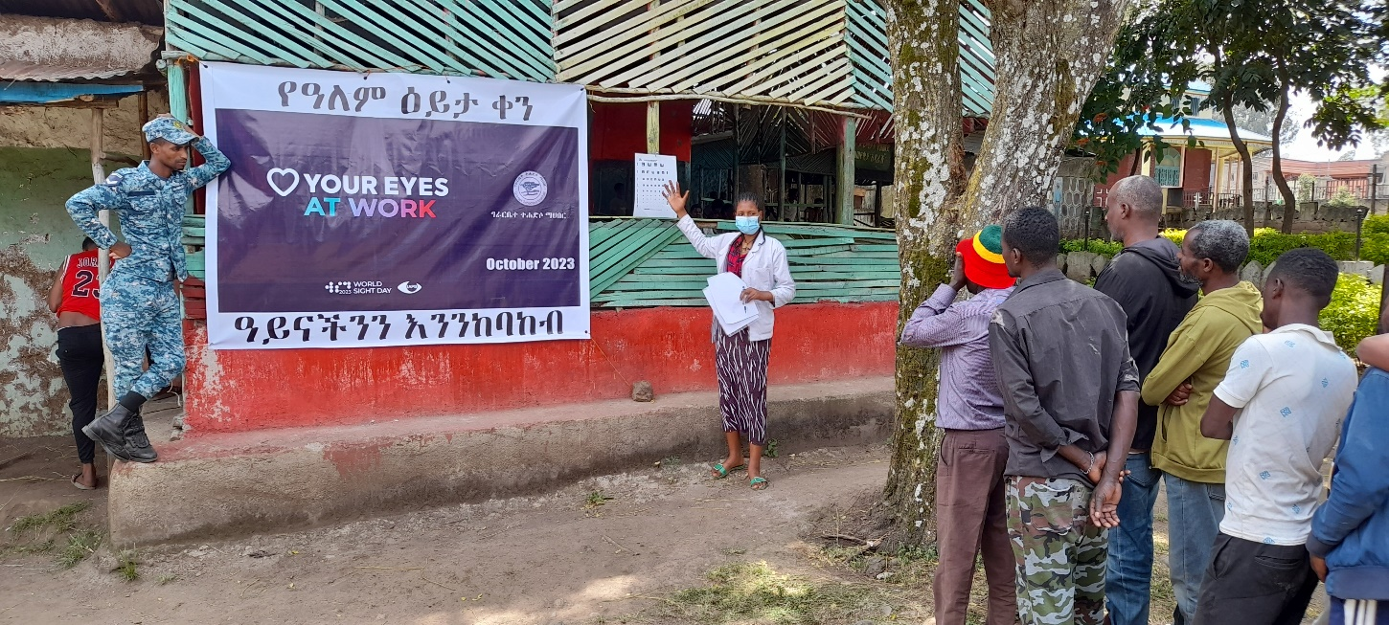

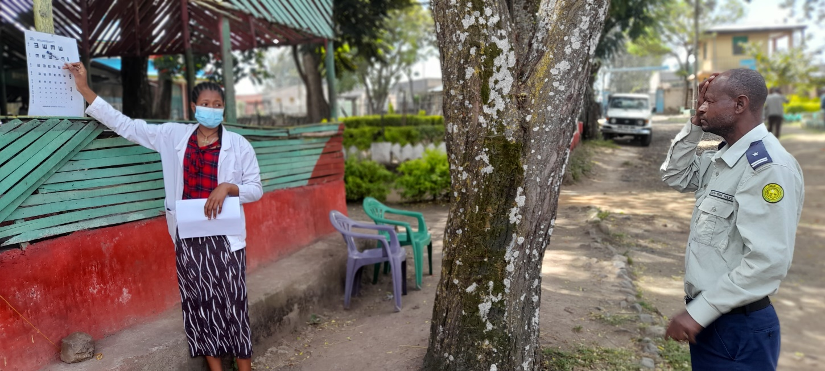

**GTM Butajira team celeberated World Sight Day by providing free eye examination for staff and jail inmates at Butajira prison**

* + 1. **Stories of Change**

**WOSILA SEID**

Wosila Seid, a 72-year-old widow, has faced a series of challenges that have significantly impacted her daily life. A tragic accident eight years ago stripped her ability to walk, rendering her entirely dependent on others due to her physical limitations. Besides, her poor hearing capacity also makes it difficult to converse effectively. Added to all of these difficult circumstances was the cataract that reduced the eyesight in both of her eyes.

After learning about GTM's eye care services from other beneficiaries, Wosila's older son took her to GTM Butajira to address her visual problems. The GTM ophthalmologist underwent an ocular examination and found out that she had bilateral dense cataracts. The ophthalmologist operated on her right eye following a pre-operative assessment.

The next day, the shield that covered her right eye was removed. Wosila, overwhelmed with gratitude, expressed her joy, thanking everyone involved in her journey to recovery. She acknowledged the profound impact of regaining her vision, stating, "It is a significant change for me. Even if I cannot perform relevant tasks, I can see what I am eating. That is a big thing for me." It was quite touching to see Wosila's emotional reaction to being able to see again. Her genuine appreciation and the heartfelt gratitude she expressed reflected the magnitude of the change in her life. Wosila experienced a renewed feeling of purpose and happiness as a result of her restored capacity to visually connect with her surroundings. Wosila will undergo cataract surgery for the left eye once the wound in the right eye has healed fully.

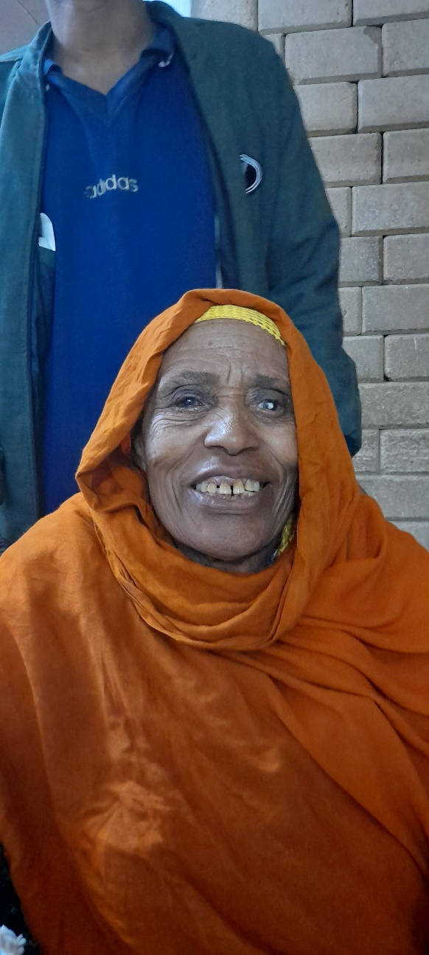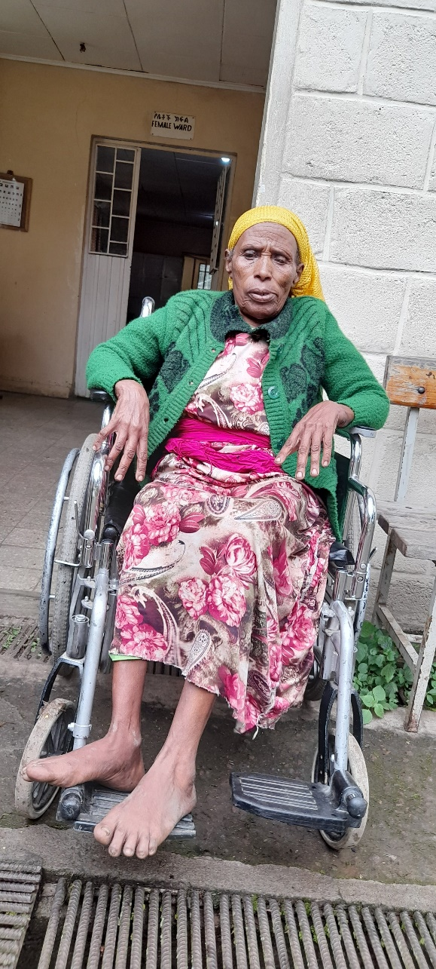

pictures showing woslila before and after the cataract surgery

* + 1. **Any other supporting documents as needed or agreed with CBM**

1. **COMMENTS FROM CBM**

The project, initially known as P1042 (formerly 4081-MYP), took place from 2021 to 2023, concluding in 2023. It aimed to enhance the efficiency of Comprehensive Eye Care, ENT, Epilepsy, and Physical Rehabilitation Services for the rural community, with a specific focus on persons with disabilities and those at risk in Butajira town and its surroundings. Despite the absence of an initially quarterly distributed work plan, the project successfully executed planned activities in each result area, adhering to the scheduled timeline. During the reporting period, the partner exceeded planned targets, reaching over 24,000 impoverished rural individuals with quality health services, including eye care, ear and hearing care, epilepsy treatment, and physical rehabilitation. The staff's additional commitment and extra hours contributed to surpassing the project's objectives.

Major findings highlight the project's success and positive impact on the targeted community. Adequate qualified staffing was ensured for the implementation of planned activities, with the following roles:3 Ophthalmic Nurse: 3,4 Optometrist: 4,2 Ophthalmologist: 2,1 Cataract surgeon: 1,3 Integrated Eye care workers: 2, and 3 Clinical Nurses. Additionally, 2 residents come to the center every quarter for hands-on training, if not regularly.

* Most of the project planned activities were executed within budget and schedule; approximately 120 patients visit the center daily seeking medical attention in specialty areas.
* Common eye health problems treated include trachoma, cataract, glaucoma, and Refractive error, with an average of 60 to 70 patients daily. Rural communities are well aware of the services.
* Dr. Uta conducts minor and major surgeries quarterly, accompanied by 2 residents during each outreach service.
* Regular health education sessions, lasting 15 minutes, are provided by an ophthalmic nurse and Health Officer in the waiting area for patients and their caregivers.
* Five TT surgeries are conducted daily at the base hospital for free, requiring a registration card fee of ETB 50.00. Patients receive food and bed services.
* Weekly, 40 to 50 patients undergo surgery for ETB 2,500 or free for those who cannot afford it; private clinic costs can reach ETB 20,000 or more.
* Eye glasses provision with frames of different quality ranges from ETB 290.00 to ETB 1,100. Eslor Foundation provides the glasses.
* Qualitative and quantitative data collection are emphasized, with plans for training staff on data collection, storage, analysis, and reporting skills.
* Patient satisfaction assessments are conducted verbally, identifying deviations in the provision of LV services due to a budget shortfall.
* Monthly LV case follow-up includes 3 patients, two of whom are school children.
* Fifty primary schools receive support for eye health promotion.
* Newly admitted patients’ number 25, with 5 willing to use assistive LV devices. Non-optical devices like torch lights and canes are provided for rehabilitation support.
* Two staff members received LV training from Dr. Karin, the global LV advisor.
* Budget utilization was at a 74.81% burn rate.
* Timely delivery of quality narrative, statistics, and financial reporting was achieved.
* GTM staff are responsive to various communications from CBM.
* GTM maintains good collaboration with government stakeholders such as the health office, finance and economy office, and education office, as well as women and social affairs office.
* Recently delivered eye health and ENT equipment are functional, but some require calibration.
* Active and progressing procurement management, including the software.

**Major Challenges:**

* Low patient flow, especially for TT surgery, attributed to cultural and religious reasons.
* ORBIS project intervention overlaps, providing incentives to patients (e.g., training fees, surgery payment).
* Tribal conflict hindered outreach activity implementation in some areas.

Resuming this eye health project after a temporary halt can yield several major benefits:

* **Enhanced Accessibility to Eye Care Services:**
  + - The project's resumption allows for the re-establishment and expansion of eye care services, making them more accessible to community members.
    - Increased availability of eye care facilities and services can contribute to early detection and timely intervention for various eye conditions, promoting overall eye health.
* **Data Continuity and Impact Assessment:**
* The project's continuation enables the collection of additional data to assess its impact on the community.
* Analyzing the data helps in understanding the effectiveness of the interventions, identifying areas for improvement, and making informed decisions for future phases or similar projects.
* Partnership Strengthening:
* The hiatus might have strained relationships with project partners and stakeholders. Resuming the project provides an opportunity to re-engage and strengthen these collaborations.
* Strong partnerships can lead to better resource mobilization, knowledge sharing, and a more comprehensive approach to addressing eye health issues.

In summary, I would suggest to further fund the program at GTM to resume the eye health project after a phase-out period, because it would bring about sustained positive impacts on community eye health, accessibility to eye care services, education, sustainability, data assessment, partnerships, and adaptation to challenges,

-End of document. Back to top-

1. https://www.ncbi.nlm.nih.gov/pmc/articles/PMC7724371/